|  |  |  |  |  |
| --- | --- | --- | --- | --- |
|  |  | | |  |
|  |  | | |  |
|  | AWD/4WD  <<Feature>> | | |  |
|  |  | | |  |
| Document Type | **Feature Document (FD)** | | |  |
| Template Version | **6.1b** | | |  |
| SysML Report Template Version | **O Beta (2021/06/09)** | | |  |
| Document ID | **ffst01.10_featuredocument_sysmlreporttemplate** | | |  |
| Document Location |  | | |  |
| Document Owner | **Document Owner Here** | | |  |
| Document Revision | **FD0** | | |  |
| Document Status | **Draft** | | |  |
| Date Issued | **2021/08/05** | | |  |
| Date Revised | **2021/08/05** | | |  |
| Document Classification | GIS1 Item Number: | **27.60/35** | |  |
| GIS2 Classification: | **Confidential** | |
|  | | | | |
|  | | | | |
| Document Approval | | | | |
| Person | Role | | Email Confirmation | Date |
|  |  | |  |  |
|  |  | |  |  |

**Auto-Generated by MagicDraw**

Printed Copies Are Uncontrolled

# Disclaimer

**This document contains Ford Motor Company Confidential information. Disclosure of the information contained in any portion of this document is not permitted without the expressed, written consent of a duly authorized representative of Ford Motor Company, Dearborn, Michigan, U.S.A.**

**Copyright, Ó 2021 Ford Motor Company**

This document contains information developed and accumulated by and for FORD MOTOR COMPANY. As such, it is a proprietary document, which, if disseminated to unauthorized persons, would provide others with restricted information, data, or procedures not otherwise available, exposing the FORD MOTOR COMPANY to potential harm.

Employees and suppliers having custody of this specification or authorized to use it must be cognizant of its proprietary nature and ensure that the information herein is not made available to unauthorized persons.

FORD MOTOR COMPANY reserves the right to protect this work as an unpublished copyrighted work in the event of an inadvertent or deliberate unauthorized publication. FORD MOTOR COMPANY also reserves its rights under copyright laws to protect this work as a published work.

This document or portions thereof shall not be distributed outside FORD MOTOR COMPANY without prior written consent. Refer all questions concerning disclosure to the author(s) or to any duly authorized representative of Ford Motor Company.

**Copyright** © **2021 Ford Motor Company**

# Contents

1.1.2 Decomposition of Functional Safety Requirement 13

Disclaimer 22

Contents 23

2 Introduction 26

2.1 Document Purpose 26

2.2 Document Scope 26

2.3 Document Audience 26

2.3.1 Stakeholder List 26

2.4 Document Organization 26

2.4.1 Document Context 26

2.4.2 Document Structure 27

2.5 Document Conventions 27

2.5.1 Requirements Templates 27

3 Feature Overview 28

3.1 Purpose and Description of Feature 28

3.2 Feature Variants 28

3.2.1 Regions & Markets 29

3.3 Input Requirements 29

3.3.1 Legal Requirements 30

3.3.2 Trustmark Requirements 30

3.3.3 Industry Standards 30

3.3.4 Attribute Requirements 30

3.4 Lessons Learned 30

3.5 Assumptions 31

3.6 References 31

3.6.1 Ford Documents 32

3.6.2 External Documents and Publications 32

3.7 Glossary 33

3.7.1 Parameters / Values 33

4 Feature Context 34

4.1 Feature Context Diagram 34

4.2 List of Influences 34

5 Feature Modeling 36

5.1 Operation Modes and States 36

5.2 Use Cases 38

5.2.1 Use Case Diagram 38

5.2.2 Actors 39

5.2.3 Use Case Descriptions 39

5.3 Driving and Operation Scenarios 43

5.4 Decision Tables 45

6 Feature Requirements 46

6.1 Functional Requirements 46

6.1.1 Error Handling 47

6.2 Non-Functional Requirements 47

6.2.1 Safety 47

6.2.2 Security 47

6.2.3 Reliability 47

6.3 HMI Requirements 47

6.4 Other Requirements 48

6.4.1 Design Requirements 48

6.4.2 Manufacturing Requirements 48

6.4.3 Service Requirements 48

6.4.4 After Sales Requirements 48

6.4.5 Process Requirements 48

6.4.6 Uncategorized Requirements 49

7 Functional Safety 50

7.1 System Behaviors for HARA 50

7.2 Safety Assumptions 50

7.3 Safety Goals 51

7.4 Functional Safety Requirements 53

7.4.1 Safety Goal: 53

7.4.2 Derivation of Functional Safety Requirements on Assumptions 55

7.5 ASIL Decomposition of Functional Safety Requirements 56

8 Architecture 57

8.1 Functional Architecture 57

8.1.1 List of Functions 57

8.2 Logical Architecture 58

8.2.1 Logical Interfaces 59

9 Open Concerns 61

10 Revision History 62

11 Appendix 63

11.1 Definitions 63

11.2 Abbreviations 63

**List of Figures**

Figure 1. 12

Figure 2: 28

Figure 3: - 28

Figure 4: 34

Figure 5: 36

Figure 6: 38

Figure 7:  55

Figure 8: 57

Figure 9: 58

**List of Tables**

Table 1: Features described in this FD 26

Table 2: Feature Variants 29

Table 3: Regions & Markets 29

Table 4: Ford internal Documents 32

Table 5: Ford internal Documents *(not specified in SysML model)* 32

Table 6: External documents and publications 32

Table 7: External documents and publications *(not specified in SysML model)* 33

Table 8: Parameters / Values used in this document *(Not supported by MagicDraw report generation)* 33

Table 9: List of Influences 35

Table 10: Operation Modes and States on 36

Table 11: Transitions between Operation Modes and States on 38

Table 12: List of Actors 39

Table 13: System Behaviors for HARA 50

Table 14: Functional Safety Assumptions 51

Table 15: Functional Safety Goals 53

Table 16: List of Functions 58

Table 17: List of Functions on 58

Table 18: Feature Interactions 59

Table 19: Feature Interactions on 59

Table 20: Open Concerns *(Not supported by MagicDraw report generation)* 61

Table 21: Definitions used in this document 63

Table 22: Abbreviations used in this document 64

# Introduction

## Document Purpose

A Feature Document (FD) document defines a Feature on [Concept Level](https://bd101001.pd2.ford.com/stages/#/workspace/209/_vv/(process/activity/_Y6ftAPI2VsW5zd82DgHb6g)). It specifies **what** the feature shall do and how it shall behave from customer perspective. It should also provide reasoning and background **why** we have the feature in the vehicle.

The FD also serves as an Item Definition as defined by ISO26262 for those features, which follow the Ford Functional Safety process. Refer [FFSG01.10 Feature Document Guideline](https://azureford.sharepoint.com/sites/GlobalFunctionalSafety/Released%20Templates%20Guidelines%20and%20Examples/Guidelines/FFSG01.10_FeatureDocument_Guideline.pdf) for how to apply the Feature Doc template for Functional Safety.

## Document Scope

This Feature Document (FD) specifies the following features:

|  |  |  |  |
| --- | --- | --- | --- |
| **Feature ID** | **Feature Name** | **Owner** | **Reference** |
| F001131 | AWD/4WD | Dave Thompson  Anthony Ward |  |

Table 1: Features described in this FD

## Document Audience

The FD is written by the feature owner of Document Owner Here. All Stakeholders, i.e., all people who have a valid interest in the feature should read and, if possible, review the FD. It needs to be guaranteed, that all stakeholders have access to the currently valid version of the FD.

### Stakeholder List

For the latest list of stakeholder of the feature and their influence refer to <Put VSEM Link here>.

|  |  |  |
| --- | --- | --- |
| **Name** | **Role** | **Stakeholder Group** |
| Hassan Abid | Engineer | MBSE |
| Fernando Leira Cortel | Engineer | MBSE |
| Anthony Ward | Feature Owner | VCSE Advanced Features |
| Lisa Wszczenko | Supervisor | VCSE Distributed Features |
| Nick Scheufler | Supervisor | VCSE Advanced Features |
| Chris Murray | Technical Expert | CIED, SDM |
| Chris Henderson | Supervisor | VCSE Advanced Features |
| Srikanth Nadella | Technical Expert | EC, Connectivity |
| Ingrid Flores | Engineer | FuSa |
| Jennifer Pastin | FDL | CX430 MCA |
| Seth Goslawski | Technical Expert | CIED, Off-Road |
| Filip Tomik | Supervisor | 4x4/AWD Cal |
| Nick McCubbin | Technical Expert | Driveline Controls |
| David Thompson | Feature Owner | VCSE Advanced Features |
| Mahmoud Kshavarz | Feature Owner | VCSE Advanced Features |
| Craig Esler | Feature Owner | eAWD & MyMode |
| Ben Ahmed | Supervisor | MBSE |
| Dave Bruns | Technical Expert | PEDM |
| Nancy Reppenhagen | FDL | P702 |
| Elvia Trujillo | Supervisor | FuSa |
| Donã Davis | FDL | P702 |

## Document Organization

### Document Context

Refer to the [Specification Structure page](http://wiki.ford.com/display/RequirementsEngineering/Specification+templates) in the [Ford RE Wiki](http://wiki.ford.com/display/RequirementsEngineering/Requirements+Engineering+for+SW+Enabled+Features) to understand how the FD relates to other Ford Requirements Documents and Specifications.

### Document Structure

The structure of this document is explained below:

**Introduction** – Explains how to use this document including responsibilities and requisite documents. Explains the terminology. Gives a clarification of the definitions, concepts and abbreviations used in the document.

**Feature Overview** – States briefly the background and the purpose of the feature, feature variants and corresponding regions and markets. Also includes input requirements, assumptions and constraints.

**Feature Context** – describes all external entities, which have an influence on the feature.

**Feature Modeling** – Contains Use Case, Driving Scenarios, State Charts to describe the functional behavior of the feature.

**Feature Requirements** – Lists functional and non-functional requirements of the feature.

**Functional Safety** – Lists System Behaviors, Safety Goals and Safety Requirements of the feature.

**Cybersecurity** – Lists Security Goals and Security Requirements of the feature.

**Architecture** – Shows the coarse architecture, which the feature requirements are deployed to. Describes the elements and the boundary of the feature as well as the decomposition and distribution of associated functions.

**Traceability Matrix** – Traceability Matrix.

**Open Concerns** – List of Open Concerns

**Revision History** – Document Change History including a list of new or modified requirements. The requirements in this document are tagged, and this section contains different types of tables listing all, new, or changed requirements by their title and page no.

**Appendix** – Appendix

## Document Conventions

### Classification of Chapters

A chapter is considered mandatory, unless the chapter or its parent chapter(s) are categorized by using the tag:

**#Classification:** Some Condition

If no requirement/other content is known for a mandatory chapter, leave a statement “Not Applicable”

Some chapters have a follow certain rules in context of specific Ford processes, e.g. Functional Safety. This is indicated at the beginning of the corresponding chapter by the tags:

**#Functional Safety:** Some process specific explanation

**#Cybersecurity:** Some process specific explanation

### Requirements Templates

Refer to “[How to use the Specification Templates](http://wiki.ford.com/display/RequirementsEngineering/How+to+use+the+Specification+Templates?src=contextnavpagetreemode)” on how to use the specification templates and the VBA macros to create/edit the requirements in the specifications.

#### **Requirements Attributes**

The templates provided by *Specification_Macros.dotm* define a list of attributes for each requirement. This helps to classify the requirement. The attributes are explained at [RE Wiki - Requirements Attributes](http://wiki.ford.com/display/RequirementsEngineering/Requirements+Attributes?src=contextnavpagetreemode).

## References

### Ford Documents

List here all Ford internal documents, which are directly related to the feature.

| **Reference** | **Title** | **Doc. ID** | **Document Location** | **Revision** |
| --- | --- | --- | --- | --- |
| Ford GIS Standard | Ford GIS Standard |  |  |  |

Table 4: Ford internal Documents

### External Documents and Publications

The list of external documents could include books, reports and online sources.

| **Reference** | **Document / Publication** | **Document Location** |
| --- | --- | --- |
| IEEE Std 1012-2004 IEEE Standard for Software Verification and Validation |  |  |
| ISO/IEC 19500-2:2003 | Information technology -- Open Distributed Processing -- Part 2 |  |
| UML Testing Profile (UTP), v1.2 |  |  |
| Wikipedia |  |  |

Table 6: External documents and publications

## Glossary

See Appendix for Definitions and Abbreviations.

### Definitions

### Abbreviations

### Parameters / Values

| **Name** | **Description** | **Range / Resolution** |
| --- | --- | --- |

Table 8: Parameters / Values used in this document

# Feature Overview

## Purpose and Description of Feature

AWD/4WD provides 4-drive traction by diverting torque from the primary axle to the secondary axle based on high-speed inputs. The feature uses various inputs like accelerator pedal position, steering wheel angle, Powertrain torque, and wheel speeds along with other vehicle dynamic inputs which are utilized by the AWD/4WD system to provide improved handling under all conditions.

## Feature Variants

|  |  |  |
| --- | --- | --- |
| **Variant Name** | **Variant Description** | **Remarks** |
| **FWD** | Variant installed for FWD-based vehicles. |  |
| **RWD** | Variant installed for RWD-based vehicles. |  |

Table 2: Feature Variants

### Regions & Markets

|  |  |  |  |  |  |  |
| --- | --- | --- | --- | --- | --- | --- |
| **Market /**  **Region**  Variant Name | **North America** | **South America** | **Europe** | **Middle East/Africa** | **Asia / Pacific** | **China** |
| **FWD** | Mandatory | Optional | Mandatory | Optional | Mandatory | Optional |
| **RWD** | Optional | No | Optional | No | No | No |

Table 3: Regions & Markets

## Input Requirements/Documents

|  |  |  |  |
| --- | --- | --- | --- |
| **Reference**  (Reference as listed in ch. “References”) | **Section/Requirement** | **Description** | **Derived Requirement**  (optional – reference to requirement in ch. “Feature Implementation Requirements”) |
| **Attribute Requirements** | | | |
|  | Example AR |  |  |
| **Ford Engineering Standards** | | | |
|  | <Example: some SDS (requirement)> |  |  |
| **Legal Regulations** | | | |
|  | Compliance with FMVSS101 | The Feature shall comply with FMVSS101. |  |
| **Industry Standards** | | | |
|  | ISO 26262 | The system should be developed according to Ford's implementation of Functional Safety. |  |
| **Other Sources** | | | |

Table 2‑1: Input Requirements/Documents

## Lessons Learned

No lessons learned specified.

## Assumptions

No Assumptions specified.

# Feature Context

## Feature Context Diagram

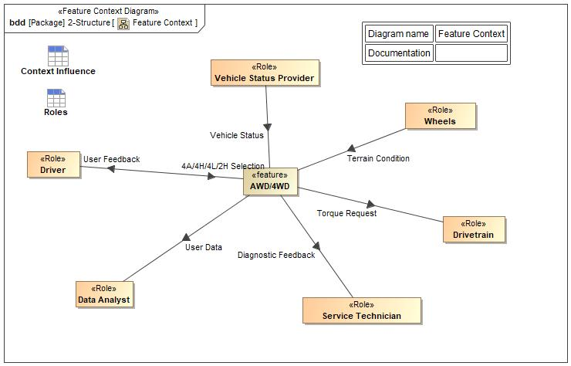

Figure 4: Feature Context

## List of Influences

|  |  |  |
| --- | --- | --- |
| **ID** | **External Entity** | **Influence Description** |
| 4A/4H/4L/2H Selection | Driver To AWD/4WD | Driver selects the 4A/4H/2H/4L Mode through the Feature HMI |
| Diagnostic Feedback | AWD/4WD To Service Technician | Technician receives Diagnostic Messages from the AWD/4WD Feature |
| Terrain Condition | Wheels To AWD/4WD | Analyze the terrain through Vehicle Status Provider |
| Torque Request | AWD/4WD To Drivetrain | Feature applies calculated Torque into the Drivetrain. |
| User Data | AWD/4WD To Data Analyst | Feature collects and monitor User Data and sends it to the company |
| User Feedback | AWD/4WD To Driver | Driver receives Torque Distribution Display, Error/Warning Messages, Diagnostic Messages |
| Vehicle Status | Vehicle Status Provider To AWD/4WD | Transmission Gear, Engine Load, Instantaneous Vehicle Speed, Acceleration Pedal Position, Steering Wheel Angle, Brake Pedal (Maybe), Wheel Speeds, Input/Output Shaft, Wheel Slip |

Table 9: List of Influences

# Feature Modeling

## Operation Modes and States

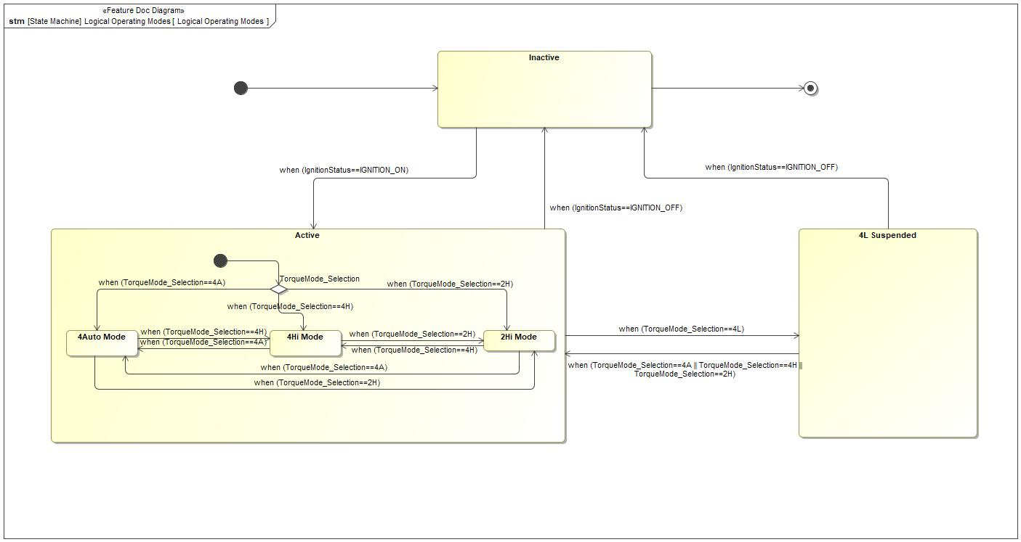

Figure 5: Logical Operating Modes

|  |  |  |
| --- | --- | --- |
| **State** | **Description** | **Requirements Reference** (optional) |
| 2Hi Mode | The feature goes into 2H when the Driver selects the mode in the feature HMI |  |
| 4Auto Mode | The feature goes into 4A when the Driver selects the mode in the feature HMI |  |
| 4Hi Mode | The feature goes into 4H when the Driver selects the mode in the feature HMI |  |
| 4L Suspended | The feature is suspended while the Driver has the 4L Mode selected in the feature HMI |  |
| Active | The feature is remains active until the Vehicle Ignition turns OFF |  |
| Inactive | The feature is inactive until the Vehicle Ignition turns ON |  |

Table 10: Operation Modes and States on Logical Operating Modes

|  |  |  |  |  |
| --- | --- | --- | --- | --- |
| **Transition ID** | **Source** | **Destination** | **Description** | **Requirements Reference**  (optional) |
| T1 | 4Hi Mode | 4Auto Mode | ChangeEvent when (TorqueMode_Selection==4A) |  |
| T2 | Active | Inactive | ChangeEvent when (IgnitionStatus==IGNITION_OFF) |  |
| T3 | 2Hi Mode | 4Auto Mode | ChangeEvent when (TorqueMode_Selection==4A) |  |
| T4 | Inactive | a |  |  |
| T5 | Active | 4L Suspended | ChangeEvent when (TorqueMode_Selection==4L) |  |
| T6 | Inactive | Active | ChangeEvent when (IgnitionStatus==IGNITION_ON) |  |
| T7 | TorqueMode_Selection | 4Hi Mode | ChangeEvent when (TorqueMode_Selection==4H) |  |
| T8 | 4Hi Mode | 2Hi Mode | ChangeEvent when (TorqueMode_Selection==2H) |  |
| T9 | TorqueMode_Selection | 4Auto Mode | ChangeEvent when (TorqueMode_Selection==4A) |  |
| T10 | 2Hi Mode | 4Hi Mode | ChangeEvent when (TorqueMode_Selection==4H) |  |
| T11 | 4Auto Mode | 4Hi Mode | ChangeEvent when (TorqueMode_Selection==4H) |  |
| T12 |  |  |  |  |
| T13 | TorqueMode_Selection | 2Hi Mode | ChangeEvent when (TorqueMode_Selection==2H) |  |
| T14 | 4L Suspended | Inactive | ChangeEvent when (IgnitionStatus==IGNITION_OFF) |  |
| T15 | 4Auto Mode | 2Hi Mode | ChangeEvent when (TorqueMode_Selection==2H) |  |
| T16 |  |  |  |  |
| T17 | 4L Suspended | Active | ChangeEvent when (TorqueMode_Selection==4A || TorqueMode_Selection==4H || TorqueMode_Selection==2H) |  |

Table 11: Transitions between Operation Modes and States on Logical Operating Modes

## Use Cases

### Use Case Diagram

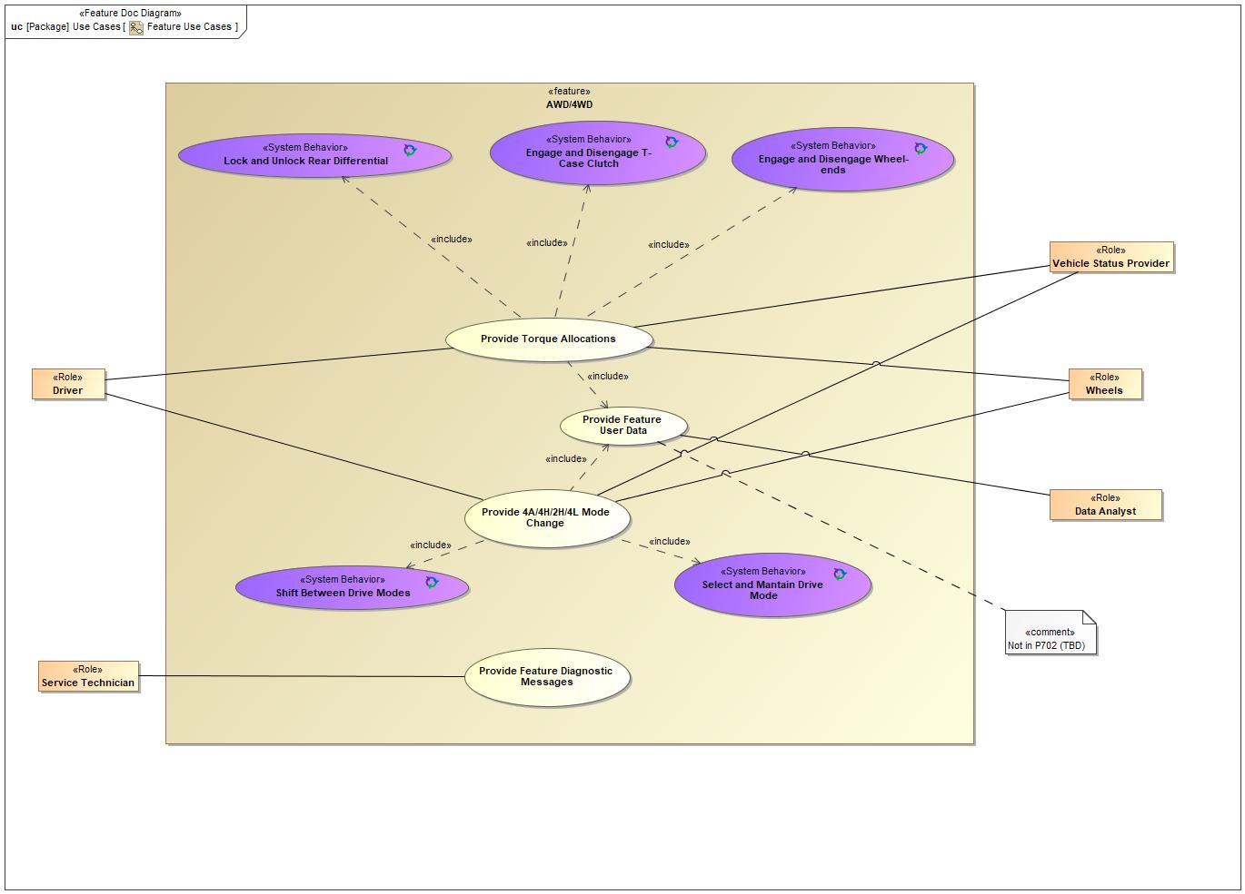

Figure 6: Feature Use Cases

### Actors

| **Actor** | **Description** |
| --- | --- |
| Data Analyst | Represents the Ford Motor Company |
| Driver | Actor/User driving the vehicle and utilizing this feature through it's HMI. |
| Service Technician | Operator reading the Feature Diagnostic Messages from the OBD-II port. |
| Vehicle Status Provider | Information from multiple system sources being provided to the feature. |
| Wheels | Surrounding conditions of the terrain where the vehicle with this feature is driving. |

Table 12: List of Actors

## Driving and Operation Scenarios

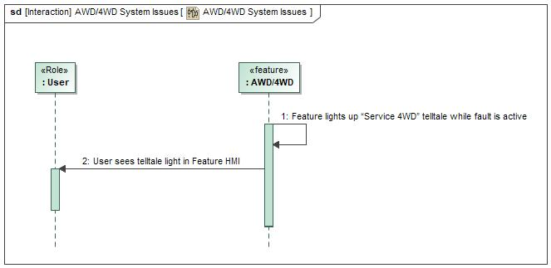

Figure 7: AWD/4WD System Issues

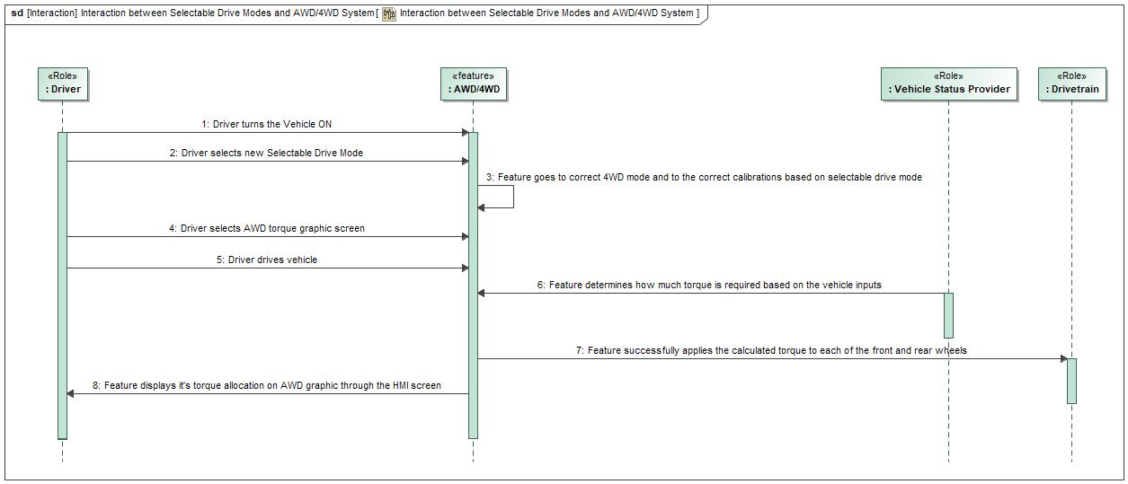

Figure 7: Interaction between Selectable Drive Modes and AWD/4WD System

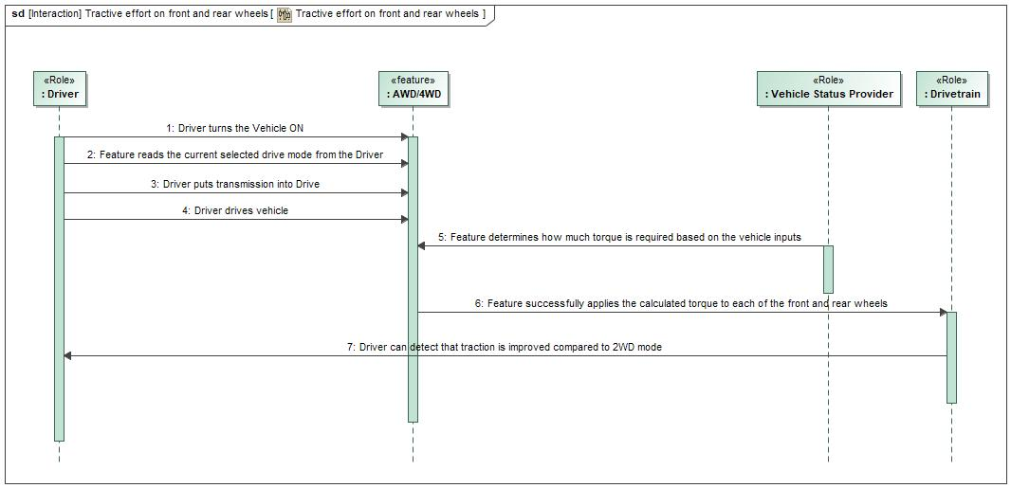

Figure 7: Tractive effort on front and rear wheels

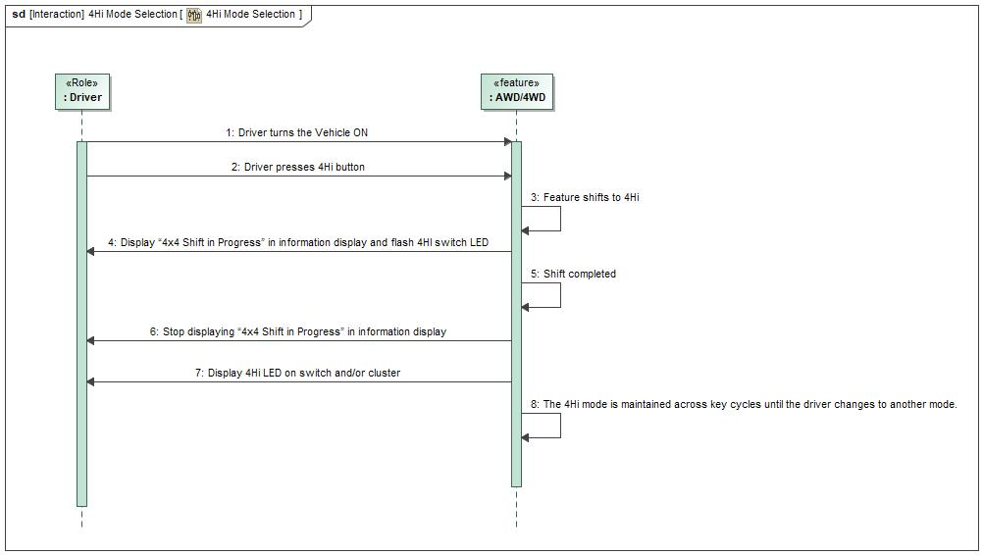

Figure 7: 4Hi Mode Selection

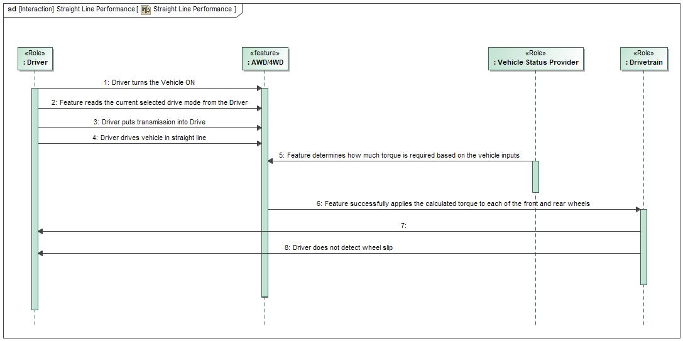

Figure 7: Straight Line Performance

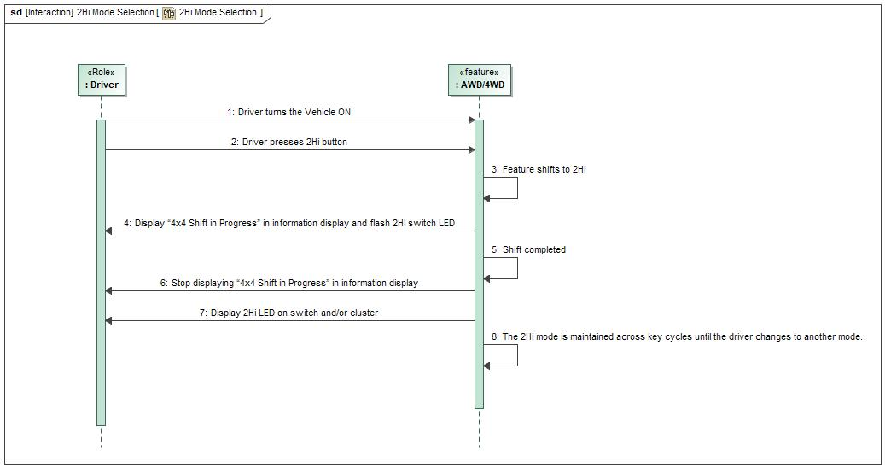

Figure 7: 2Hi Mode Selection

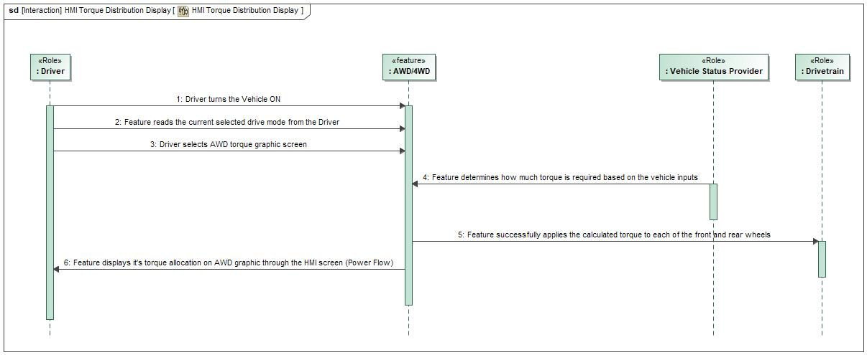

Figure 7: HMI Torque Distribution Display

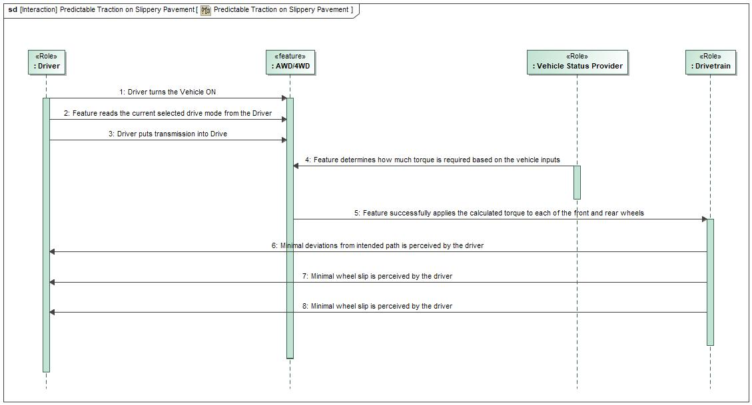

Figure 7: Predictable Traction on Slippery Pavement

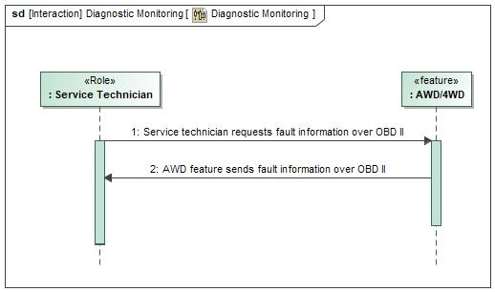

Figure 7: Diagnostic Monitoring

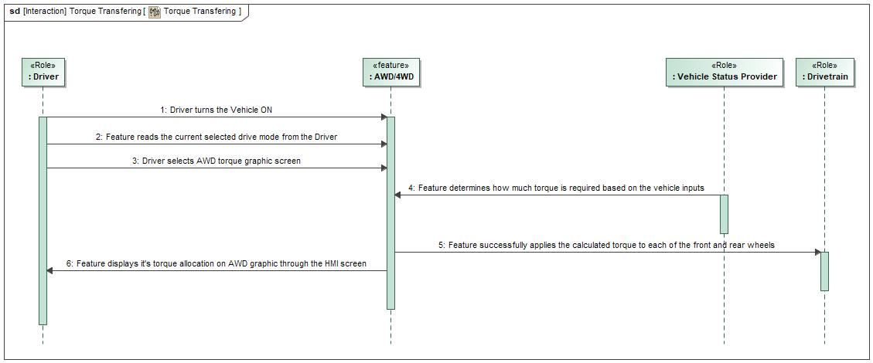

Figure 7: Torque Transfering

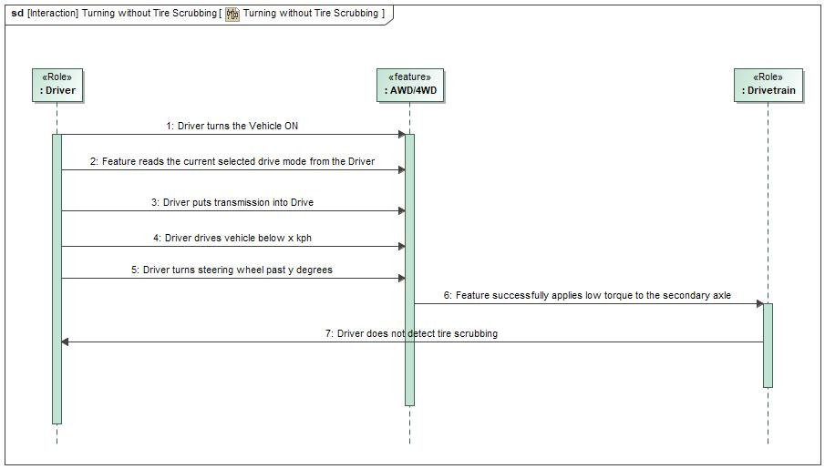

Figure 7: Turning without Tire Scrubbing

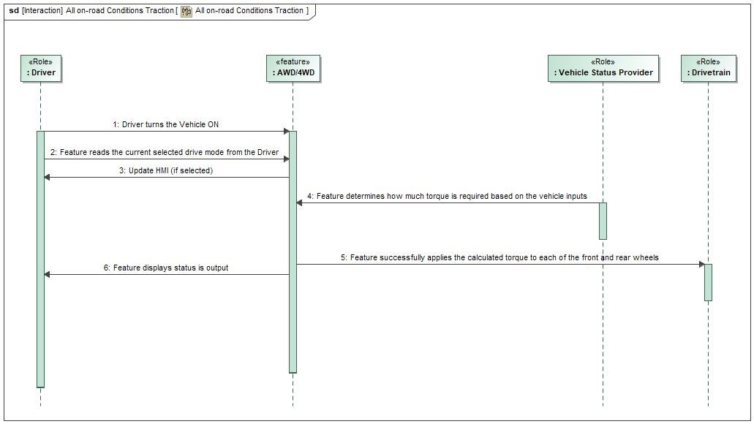

Figure 7: All on-road Conditions Traction

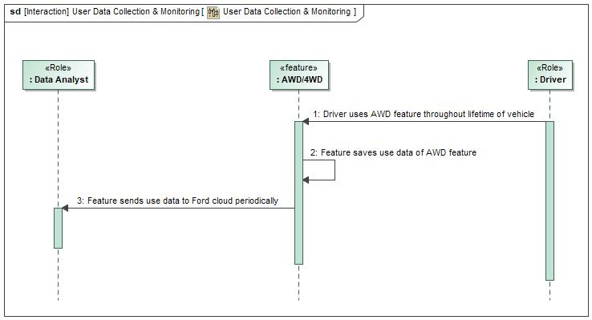

Figure 7: User Data Collection & Monitoring

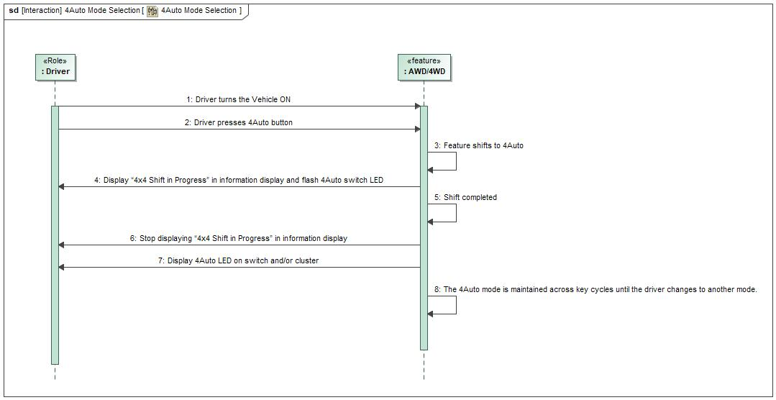

Figure 7: 4Auto Mode Selection

### Driving and Operation Scenariors Descriptions

Predictable Traction on Slippery Pavement

|  |  |  |
| --- | --- | --- |
| **Actors** | Primary | Driver |
| Secondary | Vehicle Status Provider |
| Secondary | Drivetrain |
| **Subject** |  | AWD/4WD |
| **Description** |  | As a driver, I want predictable traction on slippery pavement and turns. |
| **Preconditions** | PreC1 | Current drive mode is 4Hi/AWD ON |
| PreC2 | Vehicle Ignition RUN |
| **Triggers** | T1 | Passive based on Preconditions |
| **Main Flow Description** |  | Feature allocates torque to prevent wheel slip |
| **Main Flow** | M1 | Driver turns the Vehicle ON |
| M2 | Feature reads the current selected drive mode from the Driver |
| M3 | Driver puts transmission into Drive |
| M4 | Driver drives vehicle |
| M5 | Feature determines how much torque is required based on the vehicle inputs |
| M6 | Feature successfully applies the calculated torque to each of the front and rear wheels |
| M7 | Minimal deviations from intended path is perceived by the driver |
| M8 | Minimal wheel slip is perceived by the driver |

Torque Transfering

|  |  |  |
| --- | --- | --- |
| **Actors** | Primary | Driver |
| Secondary | Vehicle Status Provider |
| Secondary | Drivetrain |
| **Subject** |  | AWD/4WD |
| **Description** |  | As a driver, I want torque to be transferred to a wheel or combination of wheels to improve handling and traction. |
| **Preconditions** | PreC1 | Current drive mode is 4Hi/AWD ON |
| PreC2 | Vehicle Ignition RUN |
| **Triggers** | T1 | Passive based on Preconditions |
| **Main Flow Description** |  | Feature allocates the required torque based on the inputs and displays the torque distribution to the Driver through the HMI, if it has been selected |
| **Main Flow** | M1 | Driver turns the Vehicle ON |
| M2 | Feature reads the current selected drive mode from the Driver |
| M3 | Driver selects AWD torque graphic screen |
| M4 | Feature determines how much torque is required based on the vehicle inputs |
| M5 | Feature successfully applies the calculated torque to each of the front and rear wheels |
| M6 | Feature displays it's torque allocation through the HMI screen |

All on-road Conditions Traction

|  |  |  |
| --- | --- | --- |
| **Actors** | Primary | Driver |
| Secondary | Vehicle Status Provider |
| Secondary | Drivetrain |
| **Subject** |  | AWD/4WD |
| **Description** |  | As a driver, I want seamless traction on all on-road conditions |
| **Preconditions** | PreC1 | AWD torque graphic screen is selected on cluster |
| PreC2 | Current drive mode is 4Hi/AWD ON |
| PreC3 | Vehicle Ignition RUN |
| **Triggers** | T1 | Passive based on Preconditions |
| **Main Flow Description** |  | Feature allocates the required torque based on the inputs and displays the torque distribution to the Driver through the HMI, if it has been selected |
| **Main Flow** | M1 | Driver sets the Vehicle ignition to RUN |
| M2 | Feature reads the current selected drive mode from the Driver |
| M3 | Update HMI (if selected) |
| M4 | Feature determines how much torque is required based on the vehicle inputs |
| M5 | Feature successfully applies the calculated torque to each of the front and rear wheels |
| M6 | Feature displays it's torque allocation on HMI screen |

Straight Line Performance

|  |  |  |
| --- | --- | --- |
| **Actors** | Primary | Driver |
| Secondary | Vehicle Status Provider |
| Secondary | Drivetrain |
| **Subject** |  | AWD/4WD |
| **Description** |  | As a driver, I want straight line performance driving on dry pavement. |
| **Preconditions** | PreC1 | Current drive mode is 4Hi/AWD ON |
| PreC2 | Vehicle Ignition RUN |
| **Triggers** | T1 | Passive based on Preconditions |
| **Main Flow Description** |  | Feature allocates torque to prevent wheel slip |
| **Main Flow** | M1 | Driver turns the Vehicle ON |
| M2 | Feature reads the current selected drive mode from the Driver |
| M3 | Driver puts transmission into Drive |
| M4 | Driver drives vehicle in straight line |
| M5 | Feature determines how much torque is required based on the vehicle inputs |
| M6 | Feature successfully applies the calculated torque to each of the front and rear wheels |
| M7 | Driver does not detect deviations from straight line driving |
| M8 | Driver does not detect wheel slip |

2Hi Mode Selection

|  |  |  |
| --- | --- | --- |
| **Actors** | Primary | Driver |
| Secondary |  |
| **Subject** |  | AWD/4WD |
| **Description** |  | As a driver, when I press 2Hi button, I want the vehicle to drive in 2WD mode so that I can save fuel economy compared to other modes |
| **Preconditions** | PreC1 | Not in 4L |
| PreC2 | Vehicle Ignition RUN |
| PreC3 | Vehicle can be stationary or in motion |
| **Triggers** | T1 | Driver presses 2Hi button |
| **Main Flow Description** |  | Feature goes to 2Hi mode and lights up 2Hi LED on button |
| **Main Flow** | M1 | Driver turns the Vehicle ON |
| M2 | Driver presses 2Hi button |
| M3 | Feature shifts to 2Hi |
| M4 | Display “4x4 Shift in Progress” in information display and flash 2Hi switch LED |
| M5 | Shift completed |
| M6 | Stop displaying “4x4 Shift in Progress” in information display |
| M7 | Display 2Hi LED on switch and/or cluster |
| M8 | The 2Hi mode is maintained across key cycles until the driver changes to another mode |
| **Postconditions** | PostC1 | 2H Feature Mode is selected across key cycles |

Diagnostic Monitoring

|  |  |  |
| --- | --- | --- |
| **Actors** | Primary | Service Technician |
| Secondary |  |
| **Subject** |  | AWD/4WD |
| **Description** |  | As a service tech or assembly plant employee, I want to be able to easily diagnose any AWD/4WD customer or assembly/build issues. |
| **Preconditions** | PreC1 | OBD is connected |
| **Triggers** | T1 | AWD system has fault |
| **Main Flow Description** |  | Feature sends error state of AWD system to service technician by the OBD II system |
| **Main Flow** | M1 | Service technician requests fault information over OBD II |
| M2 | AWD feature sends fault information over OBD I |

HMI Torque Distribution Display

|  |  |  |
| --- | --- | --- |
| **Actors** | Primary | Driver |
| Secondary | Vehicle Status Provider |
| Secondary | Drivetrain |
| **Subject** |  | AWD/4WD |
| **Description** |  | As a driver, I want the ability to see an HMI graphic showing torque delivered to front or back wheels and a change on the Feature Mode. |
| **Preconditions** | PreC1 | AWD torque graphic screen is selected on cluster |
| PreC2 | Current drive mode is 4Hi/AWD ON |
| PreC3 | Vehicle Ignition RUN |
| **Triggers** | T1 | Passive based on Preconditions |
| **Main Flow Description** |  | Feature allocates the required torque based on the inputs and displays the torque distribution to the Driver through the HMI, if it has been selected |
| **Main Flow** | M1 | Driver turns the Vehicle ON |
| M2 | Feature reads the current selected drive mode from the Driver |
| M3 | Driver selects AWD torque graphic screen |
| M4 | Feature determines how much torque is required based on the vehicle inputs |
| M5 | Feature successfully applies the calculated torque to each of the front and rear wheels |
| M6 | Feature displays it's torque allocation on AWD graphic through the HMI screen (Power Flow) |

4Hi Mode Selection

|  |  |  |
| --- | --- | --- |
| **Actors** | Primary | Driver |
| Secondary |  |
| **Subject** |  | AWD/4WD |
| **Description** |  | As a driver, when I press 4Hi button, I want the vehicle to drive in 4Hi mode so that I can drive with higher traction in specific driving scenarios. |
| **Preconditions** | PreC1 | Not in 4L |
| PreC2 | Vehicle Ignition RUN |
| PreC3 | Vehicle can be stationary or in motion |
| **Triggers** | T1 | Driver presses 4Hi button |
| **Main Flow Description** |  | Feature goes to 4Hi mode and lights up 4Hi LED on button |
| **Main Flow** | M1 | Driver turns the Vehicle ON |
| M2 | Driver presses 4Hi button |
| M3 | Feature shifts to 4Hi |
| M4 | Display “4x4 Shift in Progress” in information display and flash 4Hi switch LED |
| M5 | Shift completed |
| M6 | Stop displaying “4x4 Shift in Progress” in information display |
| M7 | Display 4Hi LED on switch and/or cluster |
| M8 | The 4Hi mode is maintained across key cycles until the driver changes to another mode |
| **Postconditions** | PostC1 | 4H Feature Mode is selected across key cycles |

Interaction between Selectable Drive Modes and AWD/4WD System

|  |  |  |
| --- | --- | --- |
| **Actors** | Primary | Driver |
| Secondary | Vehicle Status Provider |
| Secondary | Drivetrain |
| **Subject** |  | AWD/4WD |
| **Description** |  | As a driver, I want seamless interaction between vehicle selectable drive modes and AWD/4WD systems (drive mode optimization with fuel economy). |
| **Preconditions** | PreC1 | Vehicle Ignition RUN |
| **Triggers** | T1 | Driver Selects a new Selectable Drive Mode |
| **Main Flow Description** |  | Feature updates it’s behavior based on selected drive mode |
| **Main Flow** | M1 | Driver turns the Vehicle ON |
| M2 | Driver selects new Selectable Drive Mode |
| M3 | Feature goes to correct 4WD mode and to the correct calibrations based on selectable drive mode |
| M4 | Driver selects AWD torque graphic screen |
| M5 | Driver drives vehicle |
| M6 | Feature determines how much torque is required based on the vehicle inputs |
| M7 | Feature successfully applies the calculated torque to each of the front and rear wheels |
| M8 | Feature displays it's torque allocation on AWD graphic through the HMI screen |

Turning without Tire Scrubbing

|  |  |  |
| --- | --- | --- |
| **Actors** | Primary | Driver |
| Secondary | Drivetrain |
| **Subject** |  | AWD/4WD |
| **Description** |  | As a driver in normal operation (not in 4Hi or 4Lo), I want to turn without tire scrubbing on dry pavement |
| **Preconditions** | PreC1 | Current drive mode is AWD ON |
| PreC2 | Steering Wheel Angle > y deg |
| PreC3 | Vehicle Ignition RUN |
| PreC4 | Vehicle speed < x kph |
| **Triggers** | T1 | Passive based on Preconditions |
| **Main Flow Description** |  | Feature allocates low torque to the secondary axle when the vehicle speed is low and steering wheel angle is high |
| **Main Flow** | M1 | Driver turns the Vehicle ON |
| M2 | Feature reads the current selected drive mode from the Driver |
| M3 | Driver puts transmission into Drive |
| M4 | Driver drives vehicle below x kph |
| M5 | Driver turns steering wheel past y degrees |
| M6 | Feature successfully applies low torque to the secondary axle |
| M7 | Driver does not detect tire scrubbing |

4Auto Mode Selection

|  |  |  |
| --- | --- | --- |
| **Actors** | Primary | Driver |
| Secondary |  |
| **Subject** |  | AWD/4WD |
| **Description** |  | As a driver, when I press 4Auto button, I want the vehicle to drive in AWD mode so that I can drive with higher traction in specific driving scenarios. |
| **Preconditions** | PreC1 | Not in 4L |
| PreC2 | Vehicle Ignition RUN |
| PreC3 | Vehicle can be stationary or in motion |
| **Triggers** | T1 | Driver presses 4A button |
| **Main Flow Description** |  | Feature goes to 4A mode and lights up 4A LED on button |
| **Main Flow** | M1 | Driver turns the Vehicle ON |
| M2 | Driver presses 4A button |
| M3 | Feature shifts to 4A |
| M4 | Display “4x4 Shift in Progress” in information display and flash 4A switch LED |
| M5 | Shift completed |
| M6 | Stop displaying “4x4 Shift in Progress” in information display |
| M7 | Display 4A LED on switch and/or cluster |
| M8 | The 4A mode is maintained across key cycles until the driver changes to another mode |
| **Postconditions** | PostC1 | 4A Feature Mode is selected across key cycles |

AWD/4WD System Issues

|  |  |  |
| --- | --- | --- |
| **Actors** | Primary | User |
| Secondary |  |
| **Subject** |  | AWD/4WD |
| **Description** |  | As a customer, I want to understand if there are any issues or failures of my AWD/4WD system so that I can maintain usage of my vehicle and prevent any further damage or safety concerns. |
| **Preconditions** | PreC1 | Vehicle Ignition RUN |
| **Triggers** | T1 | AWD system has fault |
| **Main Flow Description** |  | Feature lights up “Service 4WD” telltale when fault occurs |
| **Main Flow** | M1 | Feature lights up “Service 4WD” telltale while fault is active |

User Data Collection & Monitoring

|  |  |  |
| --- | --- | --- |
| **Actors** | Primary | Data Analyst |
| Secondary | Driver |
| **Subject** |  | AWD/4WD |
| **Description** |  | As Ford Motor Company, we would like to have the capability to collect and monitor AWD/4WD user data, system behavior and diagnostics remotely. |
| **Preconditions** | PreC1 | Vehicle is connected to Ford Cloud |
| **Triggers** | T1 | Passive based on Preconditions |
| **Main Flow Description** |  | Feature collects and sends feature use data to Ford cloud |
| **Main Flow** | M1 | Driver uses AWD feature throughout lifetime of vehicle |
| M2 | Feature saves use data of AWD feature |
| M3 | Feature sends use data to Ford cloud periodically |

Tractive effort on front and rear wheels

|  |  |  |
| --- | --- | --- |
| **Actors** | Primary | Driver |
| Secondary | Vehicle Status Provider |
| Secondary | Drivetrain |
| **Subject** |  | AWD/4WD |
| **Description** |  | As a driver, I want front and rear wheels capable of tractive effort in rain or snow. |
| **Preconditions** | PreC1 | Current drive mode is 4Hi/AWD ON |
| PreC2 | Sonw or water in the road |
| PreC3 | Vehicle Ignition RUN |
| **Triggers** | T1 | Passive based on Preconditions |
| **Main Flow Description** |  | Feature allocates torque to prevent wheel slip |
| **Main Flow** | M1 | Driver turns the Vehicle ON |
| M2 | Feature reads the current selected drive mode from the Driver |
| M3 | Driver puts transmission into Drive |
| M4 | Driver drives vehicle |
| M5 | Feature determines how much torque is required based on the vehicle inputs |
| M6 | Feature successfully applies the calculated torque to each of the front and rear wheels |
| M7 | Driver can detect that traction is improved compared to 2WD mode |

# Feature Requirements

## Functional Requirements

Connectivity

The AWD system shall store and transmit AWD usage data, AWD system behavior and AWD diagnostic data.

|  |  |  |  |  |  |  |  |
| --- | --- | --- | --- | --- | --- | --- | --- |
| Requirement ID: | | | | | | | |
| **Rationale** |  | | | | | | |
| **Acceptance Criteria** |  | | | | | | |
| **Notes** | The requirements below apply to FWD vehicles with AWD or 4WD in 4A mode. | | | | | | |
| **Source** |  | | | | | **Owner** | Dave Thompson  Anthony Ward |
| **Source Req.** |  | | | | | **V&V Method** |  |
| **Type** |  | | | **Priority** | 1 - High | **Status** | In-Progress |
| [Req. Template](http://wiki.ford.com/display/RequirementsEngineering/Requirements+Attributes) Version | | 6.0 | End of Requirement | | | | |

Snowplow

While the snowplow is detected by the wire harness connection, the AWD system shall provide torque to both axles to meet the increased load.

|  |  |  |  |  |  |  |  |
| --- | --- | --- | --- | --- | --- | --- | --- |
| Requirement ID: | | | | | | | |
| **Rationale** |  | | | | | | |
| **Acceptance Criteria** |  | | | | | | |
| **Notes** | The requirements below apply to FWD vehicles with AWD or 4WD in 4A mode. | | | | | | |
| **Source** |  | | | | | **Owner** | Dave Thompson  Anthony Ward |
| **Source Req.** |  | | | | | **V&V Method** |  |
| **Type** |  | | | **Priority** | 1 - High | **Status** | In-Progress |
| [Req. Template](http://wiki.ford.com/display/RequirementsEngineering/Requirements+Attributes) Version | | 6.0 | End of Requirement | | | | |

Compact Spare Tire

If a compact spare tire is mounted on the vehicle, the AWD system shall limit the maximum amount of torque sent to the secondary axle.

|  |  |  |  |  |  |  |  |
| --- | --- | --- | --- | --- | --- | --- | --- |
| Requirement ID: | | | | | | | |
| **Rationale** |  | | | | | | |
| **Acceptance Criteria** |  | | | | | | |
| **Notes** | The requirements below apply to FWD vehicles with AWD or 4WD in 4A mode. | | | | | | |
| **Source** |  | | | | | **Owner** | Dave Thompson  Anthony Ward |
| **Source Req.** |  | | | | | **V&V Method** |  |
| **Type** |  | | | **Priority** | 1 - High | **Status** | In-Progress |
| [Req. Template](http://wiki.ford.com/display/RequirementsEngineering/Requirements+Attributes) Version | | 6.0 | End of Requirement | | | | |

Key Off Load

The AWD system shall fulfill the KOL requirements in all of it's modules that remain active when the ignition position is Off.

|  |  |  |  |  |  |  |  |
| --- | --- | --- | --- | --- | --- | --- | --- |
| Requirement ID: | | | | | | | |
| **Rationale** |  | | | | | | |
| **Acceptance Criteria** |  | | | | | | |
| **Notes** | The requirements below apply to FWD vehicles with AWD or 4WD in 4A mode. | | | | | | |
| **Source** |  | | | | | **Owner** | Dave Thompson  Anthony Ward |
| **Source Req.** |  | | | | | **V&V Method** |  |
| **Type** |  | | | **Priority** | 1 - High | **Status** | In-Progress |
| [Req. Template](http://wiki.ford.com/display/RequirementsEngineering/Requirements+Attributes) Version | | 6.0 | End of Requirement | | | | |

Thermal Torque Limiting

The AWD system shall limit the maximum amount of torque sent to the secondary axle to prevent overheating of the AWD system.

|  |  |  |  |  |  |  |  |
| --- | --- | --- | --- | --- | --- | --- | --- |
| Requirement ID: | | | | | | | |
| **Rationale** |  | | | | | | |
| **Acceptance Criteria** |  | | | | | | |
| **Notes** | The requirements below apply to FWD vehicles with AWD or 4WD in 4A mode. | | | | | | |
| **Source** |  | | | | | **Owner** | Dave Thompson  Anthony Ward |
| **Source Req.** |  | | | | | **V&V Method** |  |
| **Type** |  | | | **Priority** | 1 - High | **Status** | In-Progress |
| [Req. Template](http://wiki.ford.com/display/RequirementsEngineering/Requirements+Attributes) Version | | 6.0 | End of Requirement | | | | |

Definition of 2H Mode

While 2H is active, AWD shall send torque only to the primary axle.

|  |  |  |  |  |  |  |  |
| --- | --- | --- | --- | --- | --- | --- | --- |
| Requirement ID: | | | | | | | |
| **Rationale** |  | | | | | | |
| **Acceptance Criteria** |  | | | | | | |
| **Notes** | The requirements below apply to RWD vehicles with AWD or 4WD in 2H or 4H mode. | | | | | | |
| **Source** |  | | | | | **Owner** | Dave Thompson  Anthony Ward |
| **Source Req.** |  | | | | | **V&V Method** |  |
| **Type** |  | | | **Priority** | 1 - High | **Status** | In-Progress |
| [Req. Template](http://wiki.ford.com/display/RequirementsEngineering/Requirements+Attributes) Version | | 6.0 | End of Requirement | | | | |

Ascending a Grade

While ascending a grade, the AWD system shall provide torque to both axles to meet the increased load.

|  |  |  |  |  |  |  |  |
| --- | --- | --- | --- | --- | --- | --- | --- |
| Requirement ID: | | | | | | | |
| **Rationale** |  | | | | | | |
| **Acceptance Criteria** |  | | | | | | |
| **Notes** | The requirements below apply to FWD vehicles with AWD or 4WD in 4A mode. | | | | | | |
| **Source** |  | | | | | **Owner** | Dave Thompson  Anthony Ward |
| **Source Req.** |  | | | | | **V&V Method** |  |
| **Type** |  | | | **Priority** | 1 - High | **Status** | In-Progress |
| [Req. Template](http://wiki.ford.com/display/RequirementsEngineering/Requirements+Attributes) Version | | 6.0 | End of Requirement | | | | |

Launch Boost

While vehicle accelerator pedal is pressed and vehicle is below x kph, the AWD system shall provide torque to both axles.

|  |  |  |  |  |  |  |  |
| --- | --- | --- | --- | --- | --- | --- | --- |
| Requirement ID: | | | | | | | |
| **Rationale** |  | | | | | | |
| **Acceptance Criteria** |  | | | | | | |
| **Notes** | The requirements below apply to FWD vehicles with AWD or 4WD in 4A mode. | | | | | | |
| **Source** |  | | | | | **Owner** | Dave Thompson  Anthony Ward |
| **Source Req.** |  | | | | | **V&V Method** |  |
| **Type** |  | | | **Priority** | 1 - High | **Status** | In-Progress |
| [Req. Template](http://wiki.ford.com/display/RequirementsEngineering/Requirements+Attributes) Version | | 6.0 | End of Requirement | | | | |

Torque Ramping

The AWD system shall ramp between torque set point values to prevent driver detectable jerk.

|  |  |  |  |  |  |  |  |
| --- | --- | --- | --- | --- | --- | --- | --- |
| Requirement ID: | | | | | | | |
| **Rationale** |  | | | | | | |
| **Acceptance Criteria** |  | | | | | | |
| **Notes** | The requirements below apply to FWD vehicles with AWD or 4WD in 4A mode. | | | | | | |
| **Source** |  | | | | | **Owner** | Dave Thompson  Anthony Ward |
| **Source Req.** |  | | | | | **V&V Method** |  |
| **Type** |  | | | **Priority** | 1 - High | **Status** | In-Progress |
| [Req. Template](http://wiki.ford.com/display/RequirementsEngineering/Requirements+Attributes) Version | | 6.0 | End of Requirement | | | | |

Definition of 4H Mode

While 4H is active, AWD shall send all available torque to the primary axle and the secondary axle.

|  |  |  |  |  |  |  |  |
| --- | --- | --- | --- | --- | --- | --- | --- |
| Requirement ID: | | | | | | | |
| **Rationale** |  | | | | | | |
| **Acceptance Criteria** |  | | | | | | |
| **Notes** | The requirements below apply to RWD vehicles with AWD or 4WD in 2H or 4H mode. | | | | | | |
| **Source** |  | | | | | **Owner** | Dave Thompson  Anthony Ward |
| **Source Req.** |  | | | | | **V&V Method** |  |
| **Type** |  | | | **Priority** | 1 - High | **Status** | In-Progress |
| [Req. Template](http://wiki.ford.com/display/RequirementsEngineering/Requirements+Attributes) Version | | 6.0 | End of Requirement | | | | |

Handling - Straight Line Driving

If turning is not wanted, then the AWD system shall provide torque to either or both axles such that straight line driving is not impaired.

|  |  |  |  |  |  |  |  |
| --- | --- | --- | --- | --- | --- | --- | --- |
| Requirement ID: | | | | | | | |
| **Rationale** |  | | | | | | |
| **Acceptance Criteria** |  | | | | | | |
| **Notes** | The requirements below apply to FWD vehicles with AWD or 4WD in 4A mode. | | | | | | |
| **Source** |  | | | | | **Owner** | Dave Thompson  Anthony Ward |
| **Source Req.** |  | | | | | **V&V Method** |  |
| **Type** |  | | | **Priority** | 1 - High | **Status** | In-Progress |
| [Req. Template](http://wiki.ford.com/display/RequirementsEngineering/Requirements+Attributes) Version | | 6.0 | End of Requirement | | | | |

Preemptive Torque

The AWD system shall provide a constant baseline torque to secondary axle dependent on selectable driveline mode and vehicle speed.

|  |  |  |  |  |  |  |  |
| --- | --- | --- | --- | --- | --- | --- | --- |
| Requirement ID: | | | | | | | |
| **Rationale** |  | | | | | | |
| **Acceptance Criteria** |  | | | | | | |
| **Notes** | The requirements below apply to FWD vehicles with AWD or 4WD in 4A mode. | | | | | | |
| **Source** |  | | | | | **Owner** | Dave Thompson  Anthony Ward |
| **Source Req.** |  | | | | | **V&V Method** |  |
| **Type** |  | | | **Priority** | 1 - High | **Status** | In-Progress |
| [Req. Template](http://wiki.ford.com/display/RequirementsEngineering/Requirements+Attributes) Version | | 6.0 | End of Requirement | | | | |

Parking Brake – Hand Brake Turning

While parking brake is active and vehicle is at high speed, the AWD system shall provide no torque to the secondary axle.

|  |  |  |  |  |  |  |  |
| --- | --- | --- | --- | --- | --- | --- | --- |
| Requirement ID: | | | | | | | |
| **Rationale** |  | | | | | | |
| **Acceptance Criteria** |  | | | | | | |
| **Notes** | The requirements below apply to FWD vehicles with AWD or 4WD in 4A mode. | | | | | | |
| **Source** |  | | | | | **Owner** | Dave Thompson  Anthony Ward |
| **Source Req.** |  | | | | | **V&V Method** |  |
| **Type** |  | | | **Priority** | 1 - High | **Status** | In-Progress |
| [Req. Template](http://wiki.ford.com/display/RequirementsEngineering/Requirements+Attributes) Version | | 6.0 | End of Requirement | | | | |

User Selection 2H Mode

When 2H is selected on the ATCM, the system shall shift to 2H mode.

|  |  |  |  |  |  |  |  |
| --- | --- | --- | --- | --- | --- | --- | --- |
| Requirement ID: | | | | | | | |
| **Rationale** |  | | | | | | |
| **Acceptance Criteria** |  | | | | | | |
| **Notes** | The requirements below apply to RWD vehicles with AWD or 4WD in 2H or 4H mode. | | | | | | |
| **Source** |  | | | | | **Owner** | Dave Thompson  Anthony Ward |
| **Source Req.** |  | | | | | **V&V Method** |  |
| **Type** |  | | | **Priority** | 1 - High | **Status** | In-Progress |
| [Req. Template](http://wiki.ford.com/display/RequirementsEngineering/Requirements+Attributes) Version | | 6.0 | End of Requirement | | | | |

Parking Brake – Hill Park

While parking brake is active and vehicle is at low speed, the AWD system shall provide torque to both axles.

|  |  |  |  |  |  |  |  |
| --- | --- | --- | --- | --- | --- | --- | --- |
| Requirement ID: | | | | | | | |
| **Rationale** |  | | | | | | |
| **Acceptance Criteria** |  | | | | | | |
| **Notes** | The requirements below apply to FWD vehicles with AWD or 4WD in 4A mode. | | | | | | |
| **Source** |  | | | | | **Owner** | Dave Thompson  Anthony Ward |
| **Source Req.** |  | | | | | **V&V Method** |  |
| **Type** |  | | | **Priority** | 1 - High | **Status** | In-Progress |
| [Req. Template](http://wiki.ford.com/display/RequirementsEngineering/Requirements+Attributes) Version | | 6.0 | End of Requirement | | | | |

Required User Request Sources

When the ATCM switch is included and contains 4auto mode, the AWD feature shall be available while 4auto is selected.

|  |  |  |  |  |  |  |  |
| --- | --- | --- | --- | --- | --- | --- | --- |
| Requirement ID: | | | | | | | |
| **Rationale** |  | | | | | | |
| **Acceptance Criteria** |  | | | | | | |
| **Notes** | The requirements below apply to FWD vehicles with AWD or 4WD in 4A mode. | | | | | | |
| **Source** |  | | | | | **Owner** | Dave Thompson  Anthony Ward |
| **Source Req.** |  | | | | | **V&V Method** |  |
| **Type** |  | | | **Priority** | 1 - High | **Status** | In-Progress |
| [Req. Template](http://wiki.ford.com/display/RequirementsEngineering/Requirements+Attributes) Version | | 6.0 | End of Requirement | | | | |

Compact Spare Tire Detection

The AWD system shall detect whether a tire more than 14% smaller than the other three tires is mounted on the vehicle.

|  |  |  |  |  |  |  |  |
| --- | --- | --- | --- | --- | --- | --- | --- |
| Requirement ID: | | | | | | | |
| **Rationale** |  | | | | | | |
| **Acceptance Criteria** |  | | | | | | |
| **Notes** | The requirements below apply to FWD vehicles with AWD or 4WD in 4A mode. | | | | | | |
| **Source** |  | | | | | **Owner** | Dave Thompson  Anthony Ward |
| **Source Req.** |  | | | | | **V&V Method** |  |
| **Type** |  | | | **Priority** | 1 - High | **Status** | In-Progress |
| [Req. Template](http://wiki.ford.com/display/RequirementsEngineering/Requirements+Attributes) Version | | 6.0 | End of Requirement | | | | |

User Selection 4H Mode

When 4H is selected on the ATCM, the system shall shift to 4H mode.

|  |  |  |  |  |  |  |  |
| --- | --- | --- | --- | --- | --- | --- | --- |
| Requirement ID: | | | | | | | |
| **Rationale** |  | | | | | | |
| **Acceptance Criteria** |  | | | | | | |
| **Notes** | The requirements below apply to RWD vehicles with AWD or 4WD in 2H or 4H mode. | | | | | | |
| **Source** |  | | | | | **Owner** | Dave Thompson  Anthony Ward |
| **Source Req.** |  | | | | | **V&V Method** |  |
| **Type** |  | | | **Priority** | 1 - High | **Status** | In-Progress |
| [Req. Template](http://wiki.ford.com/display/RequirementsEngineering/Requirements+Attributes) Version | | 6.0 | End of Requirement | | | | |

Slip – Axle Slip Minimization

While vehicle is not turning, the AWD system shall provide torque to both axles such that primary and secondary axle speed difference is minimized.

|  |  |  |  |  |  |  |  |
| --- | --- | --- | --- | --- | --- | --- | --- |
| Requirement ID: | | | | | | | |
| **Rationale** |  | | | | | | |
| **Acceptance Criteria** |  | | | | | | |
| **Notes** | The requirements below apply to FWD vehicles with AWD or 4WD in 4A mode. | | | | | | |
| **Source** |  | | | | | **Owner** | Dave Thompson  Anthony Ward |
| **Source Req.** |  | | | | | **V&V Method** |  |
| **Type** |  | | | **Priority** | 1 - High | **Status** | In-Progress |
| [Req. Template](http://wiki.ford.com/display/RequirementsEngineering/Requirements+Attributes) Version | | 6.0 | End of Requirement | | | | |

Parking Maneuver NVH

While vehicle is performing low speed maneuvers, the AWD system shall prevent noticeable driveline NVH.

|  |  |  |  |  |  |  |  |
| --- | --- | --- | --- | --- | --- | --- | --- |
| Requirement ID: | | | | | | | |
| **Rationale** |  | | | | | | |
| **Acceptance Criteria** |  | | | | | | |
| **Notes** | The requirements below apply to FWD vehicles with AWD or 4WD in 4A mode. | | | | | | |
| **Source** |  | | | | | **Owner** | Dave Thompson  Anthony Ward |
| **Source Req.** |  | | | | | **V&V Method** |  |
| **Type** |  | | | **Priority** | 1 - High | **Status** | In-Progress |
| [Req. Template](http://wiki.ford.com/display/RequirementsEngineering/Requirements+Attributes) Version | | 6.0 | End of Requirement | | | | |

Parking Maneuvers Binding

While vehicle is performing low speed maneuvers, the AWD system shall prevent driveline binding.

|  |  |  |  |  |  |  |  |
| --- | --- | --- | --- | --- | --- | --- | --- |
| Requirement ID: | | | | | | | |
| **Rationale** |  | | | | | | |
| **Acceptance Criteria** |  | | | | | | |
| **Notes** | The requirements below apply to FWD vehicles with AWD or 4WD in 4A mode. | | | | | | |
| **Source** |  | | | | | **Owner** | Dave Thompson  Anthony Ward |
| **Source Req.** |  | | | | | **V&V Method** |  |
| **Type** |  | | | **Priority** | 1 - High | **Status** | In-Progress |
| [Req. Template](http://wiki.ford.com/display/RequirementsEngineering/Requirements+Attributes) Version | | 6.0 | End of Requirement | | | | |

Handling - High Speed Turning

While vehicle is turning at high speed, the AWD system shall provide torque to both axles to minimize yaw error.

|  |  |  |  |  |  |  |  |
| --- | --- | --- | --- | --- | --- | --- | --- |
| Requirement ID: | | | | | | | |
| **Rationale** |  | | | | | | |
| **Acceptance Criteria** |  | | | | | | |
| **Notes** | The requirements below apply to FWD vehicles with AWD or 4WD in 4A mode. | | | | | | |
| **Source** |  | | | | | **Owner** | Dave Thompson  Anthony Ward |
| **Source Req.** |  | | | | | **V&V Method** |  |
| **Type** |  | | | **Priority** | 1 - High | **Status** | In-Progress |
| [Req. Template](http://wiki.ford.com/display/RequirementsEngineering/Requirements+Attributes) Version | | 6.0 | End of Requirement | | | | |

### Error Handling

Slip - Limit Powertrain Torque

If the slip on the AWD system exceeds levels that may damage the AWD system, the AWD system shall send a message to the Powertrain control module to limit Powertrain torque.

|  |  |  |  |  |  |  |  |
| --- | --- | --- | --- | --- | --- | --- | --- |
| Requirement ID: | | | | | | | |
| **Rationale** |  | | | | | | |
| **Acceptance Criteria** |  | | | | | | |
| **Notes** | The requirements below apply to FWD vehicles with AWD or 4WD in 4A mode. | | | | | | |
| **Source** |  | | | | | **Owner** | Dave Thompson  Anthony Ward |
| **Source Req.** |  | | | | | **V&V Method** |  |
| **Type** |  | | | **Priority** | 1 - High | **Status** | In-Progress |
| [Req. Template](http://wiki.ford.com/display/RequirementsEngineering/Requirements+Attributes) Version | | 6.0 | End of Requirement | | | | |

## Non-Functional Requirements

### Security

No Security Requirements specified.

### Reliability

No Reliability Requirements specified.

### Performance

Torque Transfer System Sizing

The AWD clutch system shall be appropriately sized to allow 40-80% of primary shaft torque to be transferred to secondary shaft.

|  |  |  |  |  |  |  |  |
| --- | --- | --- | --- | --- | --- | --- | --- |
| Requirement ID: | | | | | | | |
| **Rationale** |  | | | | | | |
| **Acceptance Criteria** |  | | | | | | |
| **Notes** | Non-Functional Requirements. | | | | | | |
| **Source** |  | | | | | **Owner** | Dave Thompson  Anthony Ward |
| **Source Req.** |  | | | | | **V&V Method** |  |
| **Type** |  | | | **Priority** | 1 - High | **Status** | In-Progress |
| [Req. Template](http://wiki.ford.com/display/RequirementsEngineering/Requirements+Attributes) Version | | 6.0 | End of Requirement | | | | |

Towing

While towing is detected, the AWD system shall provide torque to both axles to meet the increased load.

|  |  |  |  |  |  |  |  |
| --- | --- | --- | --- | --- | --- | --- | --- |
| Requirement ID: | | | | | | | |
| **Rationale** |  | | | | | | |
| **Acceptance Criteria** |  | | | | | | |
| **Notes** | Non-Functional Requirements. | | | | | | |
| **Source** |  | | | | | **Owner** | Dave Thompson  Anthony Ward |
| **Source Req.** |  | | | | | **V&V Method** |  |
| **Type** |  | | | **Priority** | 1 - High | **Status** | In-Progress |
| [Req. Template](http://wiki.ford.com/display/RequirementsEngineering/Requirements+Attributes) Version | | 6.0 | End of Requirement | | | | |

## HMI Requirements

Informing the Driver - Malfunctions

If the system malfunction conditions are met, the AWD system shall illuminate the service AWD telltale.

|  |  |  |  |  |  |  |  |
| --- | --- | --- | --- | --- | --- | --- | --- |
| Requirement ID: | | | | | | | |
| **Rationale** |  | | | | | | |
| **Acceptance Criteria** |  | | | | | | |
| **Notes** | The requirements below apply to FWD vehicles with AWD or 4WD in 4A mode. | | | | | | |
| **Source** |  | | | | | **Owner** | Dave Thompson  Anthony Ward |
| **Source Req.** |  | | | | | **V&V Method** |  |
| **Type** |  | | | **Priority** | 1 - High | **Status** | In-Progress |
| [Req. Template](http://wiki.ford.com/display/RequirementsEngineering/Requirements+Attributes) Version | | 6.0 | End of Requirement | | | | |

Informing the Driver - HMI Graphic

When the driver selects the appropriate menu option, the Feature HMI shall display the graphic showing torque delivered to front and/or back wheels.

|  |  |  |  |  |  |  |  |
| --- | --- | --- | --- | --- | --- | --- | --- |
| Requirement ID: | | | | | | | |
| **Rationale** |  | | | | | | |
| **Acceptance Criteria** |  | | | | | | |
| **Notes** | The requirements below apply to FWD vehicles with AWD or 4WD in 4A mode. | | | | | | |
| **Source** |  | | | | | **Owner** | Dave Thompson  Anthony Ward |
| **Source Req.** |  | | | | | **V&V Method** |  |
| **Type** |  | | | **Priority** | 1 - High | **Status** | In-Progress |
| [Req. Template](http://wiki.ford.com/display/RequirementsEngineering/Requirements+Attributes) Version | | 6.0 | End of Requirement | | | | |

## Other Requirements

### Design Requirements

*Not supported by MagicDraw report generation.*

### Manufacturing Requirements

No Manufacturing Requirements specified.

### Service Requirements

Resolution of Assembly, Build and Field Issues

The AWD system shall store and communicate descriptive diagnostic data for resolution of assembly, build and field issues that inhibit feature function.

|  |  |  |  |  |  |  |  |
| --- | --- | --- | --- | --- | --- | --- | --- |
| Requirement ID: | | | | | | | |
| **Rationale** |  | | | | | | |
| **Acceptance Criteria** |  | | | | | | |
| **Notes** | The requirements below apply to FWD vehicles with AWD or 4WD in 4A mode. | | | | | | |
| **Source** |  | | | | | **Owner** | Dave Thompson  Anthony Ward |
| **Source Req.** |  | | | | | **V&V Method** |  |
| **Type** |  | | | **Priority** | 1 - High | **Status** | In-Progress |
| [Req. Template](http://wiki.ford.com/display/RequirementsEngineering/Requirements+Attributes) Version | | 6.0 | End of Requirement | | | | |

#### **Cloud Connectivity Data Analytics Requirements**

### After Sales Requirements

No After Sales Requirements specified.

### Process Requirements

No Process Requirements specified.

# Functional Safety

## System Behaviors for HARA

|  |  |  |
| --- | --- | --- |
| **ID** | **Name** | **Description** |
| **SB-00000001119/B** | Engage and Disengage Wheel-ends | Behavior describing how the feature engages and disengages the Wheel-ends |
| **SB-00000001120/B** | Select and Mantain Drive Mode | Behavior describing how the feature selects and maintains the drive mode from it's HMI |
| **SB-00000001121/B** | Lock and Unlock Rear Differential | Behavior describing how the feature locks and unlocks the rear differential |
| **SB-00000001122/B** | Engage and Disengage T-Case Clutch | Behavior describing how the feature engages and disengages the T-Case clutch |
| **SB-00000001123/B** | Shift Between Drive Modes | Behavior describing how the feature switches between drive modes when requested |

Table 13: System Behaviors for HARA

## Functional Safety Assumptions

|  |  |  |
| --- | --- | --- |
| ID | Assumption | |
| **ASMP00001617** | **Name** | Transfer Case Down-shift at Higher Speeds |
| **Description** | At speeds greater than 20 mph, the transfer case is unable to down-shift to a lower gear setting. The transfer case will ratchet, however the vehicle will maintain normal driving condition during the attempt. |
| **Purpose** | The Transfer Case is incapable of causing UD caused by unintended downshifting. |
| **Category** | Vehicle |
| **Related Requirement IDs** |  |
| **ASMP00001618** | **Name** | Spring Load Mechanism in Park |
| **Description** | The transfer case is unable to shift to out of park if the vehicle is on a slope greater than 1 degree due to the built-in spring mechanism that stores the load. |
| **Purpose** | The Transfer Case is incapable of causing UVM due to an unintentional shift into neutral. |
| **Category** | Vehicle |
| **Related Requirement IDs** |  |
| **ASMP00001619** | **Name** | Electronic Integrated Wheel-Ends Remains Engaged |
| **Description** | The eIWEs remains engaged when there is torque applied to the driveline system. Ensuring that it is physically impossible to disengage. |
| **Purpose** | eIWEs cannot cause unintended shifts from 4WD to 2WD. |
| **Category** | Controllability |
| **Related Requirement IDs** |  |

Table 14: Functional Safety Assumptions

## Safety Goals

|  |  |  |  |  |
| --- | --- | --- | --- | --- |
| ID | Goal | | | |
|  | **Goal Name** | Prevent Degraded Vehicle Stability | | |
| **Description** | Degraded Vehicle Stability due to 4AWD malfunction shall be prevented. | | |
| **Safety Goal Concept** | Safety Goal Concept:  Warning & Recovery Concept: | | |
| **ASIL** | A | **FTTI** |  |
| **Related FSR IDs** |  | | |

Table 15: Functional Safety Goals

## Functional Safety Requirements

### Safety Goal: Prevent Degraded Vehicle Stability

**Name:** Prevent Degraded Vehicle Stability

**Purpose:** To prevent degraded vehicle stability due to sudden torque increase or locked differential during dynamic driving and a locked differential at speed.

**Text:** Degraded Vehicle Stability due to 4AWD malfunction shall be prevented.

**ASIL:** A

#### Safety Goal Concept

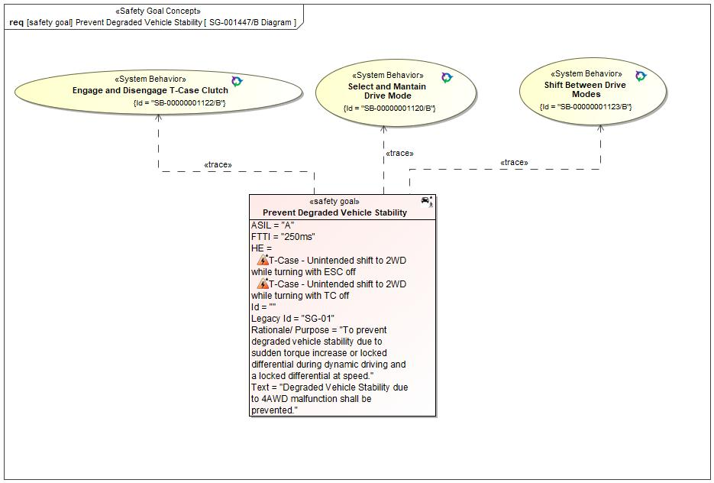

Figure 1: SG-001447/B Diagram – Prevent Degraded Vehicle Stability

*Note: The authoritative source for the Safety Goals is document “FFSD 02 Hazard Analysis* *and Risk Assessment”. The documentation of Safety Goals in this chapter (In the Argumentation for Safety Goal achievement) is for information purposes only.*

*The authoritative source for the Functional Safety Requirements is section 2.1.x.3: of this document. The documentation of Functional Safety Requirements in the following chapter (complete or summarised) is for information purposes only.*

#### Warning and Recovery Concept

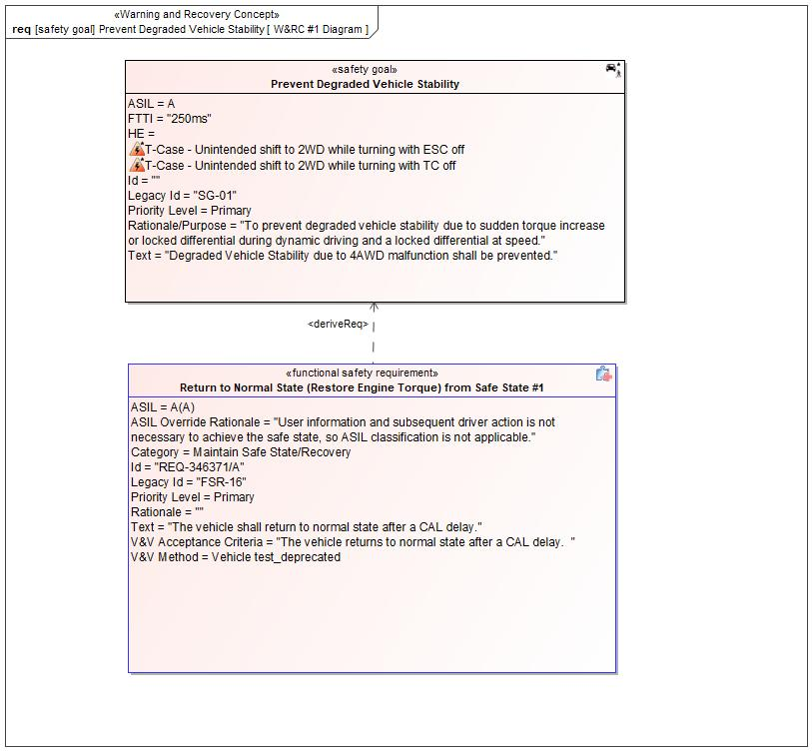

Figure 7: W&RC #1 Diagram – Prevent Degraded Vehicle Stability

### Derivation of Functional Safety Requirements on Assumptions

No Functional Safety Requirements tracing to Assumptions specified.

### ASIL Decomposition of Functional Safety Requirements

No Functional Safety Requirements with ASIL Decompositions specified.

# CyberSecurity

## Security Goals

|  |  |
| --- | --- |
| ID | Goal |

Table 18: Cybersecurity Goals

## Cybersecurity Requirements

# Architecture

## Logical Architecture

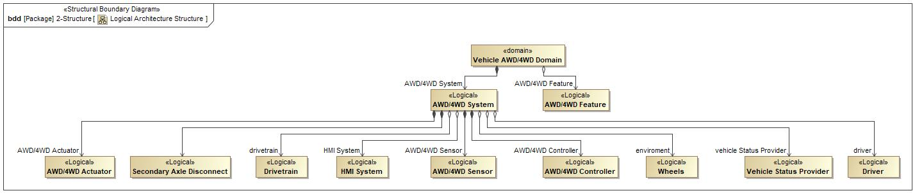

Figure 9: Logical Architecture Structure

### Logical Elements

|  |  |  |  |
| --- | --- | --- | --- |
| **Element Name** | **Description** | **Allocated Functions** | **Comments** |
|  |  |  |  |
| AWD/4WD Actuator | Logical actuator of the AWD/4WD Feature | * Request Torque Allocation |  |
| AWD/4WD Controller | Logical controller of the AWD/4WD Feature | * Determine Torque Allocation * Operation Check * Operate Feature Mode Change * KOL Monitoring |  |
| AWD/4WD Feature | Logical representation of AWD/4WD |  |  |
| AWD/4WD Sensor | Logical sensor of the AWD/4WD Feature |  |  |
| AWD/4WD System | Logical system of the AWD/4WD Feature | * Torque Operation * Feature Mode Change Management |  |
| Driver | Logical representation of the Driver for AWD/4WD |  |  |
| Drivetrain | Logical representation of the Vehicle's Drivetrain | * Apply Torque to Wheels |  |
| HMI System | Logical system representation of the AWD/4WD HMI | * Provide Torque Distribution Feedback to Driver * Receive Request for Feature Mode Change * Shifting Progress Message * Display Feature Mode Change Feedback |  |
| Secondary Axle Disconnect | Integrated Wheel-ends | * Engage/Disengage Secondary Axle |  |
| Vehicle AWD/4WD Domain | Vehicle Domain for AWD/4WD |  |  |
| Vehicle Status Provider | Provide the preconditions to the AWD/4WD Feature |  |  |
| Wheels | Logical representation of the terrain condition |  |  |

Table 19: Logical Elements

### Logical Interfaces

# Traceability Matrix

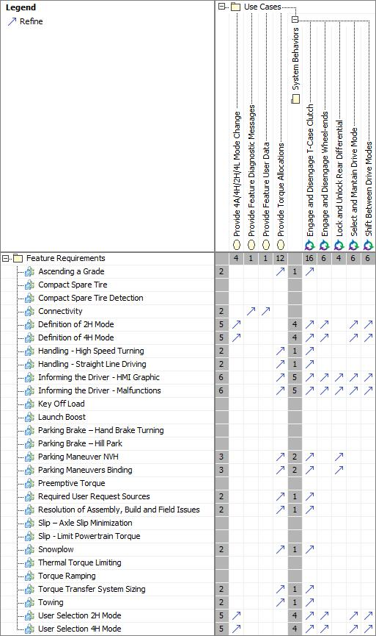

# Open Concerns

| ID | Concern Description | e-Tracker / Reference | Responsible | Status | Solution |
| --- | --- | --- | --- | --- | --- |
| 1 |  |  |  |  |  |

Table 20: Open Concerns *(Not supported by MagicDraw report generation)*

# Revision History

No Revision History found.

## Template Revisions

|  |  |  |  |  |
| --- | --- | --- | --- | --- |
| Version | Rev. | Date | Description | Responsible |
| 0 | 6 | 2015-05-26 | * Chapter “Feature Overview” and made a 2nd level heading. * Chapter “Feature Modeling” divided into 3 subchapter (“Scenarios”, “Use Cases”, “State Machines”) for different modeling methods | Jbaden1 |
| 0 | 7 | 2015-05-27 | * Table of Content updated * Template Revision History chapter added | Jbaden1 |
| 0 | 8 | 2015-07-02 | * Section “Unsettled Issues” added | Alevin7 |
| 0 | 9 | 2015-08-04 | * Section “Feature Variants” added * Section “Feature Boundary Diagram” renamed to “Feature Context Diagram” * Document Properties adapted to match needs of VBA macros | Jbaden1, Awegman1 |
| 1 | 0 | 2015-09-11 | * Section “Feature Variants” reworked * Feature Goals removed. Only “Safety Goals“ chapter remains. * Heading 2 formatting issues corrected. * Requirements / Use Cases Listing removed from traceability chapter. * Formatting of attribute table in Notation chapter corrected * Open Topics / Known Issues chapter moved to the end | Jbaden1 |
| 1 | 1 | 2015-11-16 | * Table-Styles removed (for smooth VSEM import) * Some clean-up of sections “Purpose” and “Audience” | Awegman1, jbaden1 |
| 1 | 2 | 2016-02-26 | * Minor corrections based on lessons learned from CC and PCL pilot (e.g. section market/regions) and discussion with Functional Safety Team (purpose of feature) * Footer corrected * Boundary diagram interface chapter renamed to influences. | Jbaden1 |
| 1 | 3 | 2016-02-26 | * Minor corrections after review with Whitney Keith from Functional Safety team | Jbaden1 |
| 1 | 4 | 2016-03-10 | * Some cleanup of meta-data in Word Properties | Jbaden1 |
| 1 | 5 | 2016-03-10 | * Footer formatting corrected (Issue 19) * Results from review with Functional Safety Team incorporated (Issue 20). | jbaden1 |
| 1 | 6 | 2016-04-18 | * Scenario Template added | Jbaden1 |
| 1 | 7 | 2016-04-18 | * Chapter “Operation Modes and States” moved before “Use Case” section. | Jbaden1 |
| 1 | 8 | 2016-04-18 | * Broken Wiki links repaired. | Jbaden1 |
| 2 | 0 | 2016-05-19 | * Adapted to Specification_Macros.dotm V2.0 * Requirements Templates chapter (ch. 1.7.1) no longer has an attribute table, but refers directly to the Wiki.. | Jbaden1 |
| 2 | 1 | 2016-06-10 | * Table for Context Diagram modified (lists external entities and Influence Description only) | Jbaden1 |
| 2 | 2 | 2016-07-08 | * Template version added to footer * Several hints added to the various sections * Findings from Functional Safety Team incorporated. * RE_SafetyRequirement style added | Jbaden1 |
| 2 | 3 | 2016-09-21 | * Update from Functional Safety Team incorporated (“Lessons Learned”, “System Behaviors for HARA”) | Jbaden1 |
| 2 | 4 | 2016-11-15 | * Update from Functional Safety Team incorporated (“Lessons Learned”, “System Behaviors for HARA”) * Explanatory notes made more formal | Jbaden1 |
| 3 |  |  | Skipped to synchronize with Specification_Macros.dotm |  |
| 4 |  |
| 5 | 0 | 2017-01-13 | * Meta data updated for specification macros, version 3.1 * SW Unit chapter removed for the time being * Green boxes added for user hints | Jbaden1 |
| 5 | 1 | 2017-01-18 | * Minor editorial changes | Jbaden1 |
| 6 | 0 | 2017-02-03 | * CR48: Chapter 6 renamed from “Safety” to “Functional Safety”. New sub-chapter “Safety” introduced in Non-Functional Requirements section | Jbaden1 |
| 6 | 0 | 2017-04-28 | * CR7: “RequirementsTraceability” chapter removed | Jbaden1 |
| 6 | 0 | 2017-11-15 | * CR32/53: New Cover Sheet + Disclaimer replaces FAP-150 like ones. * CR75: Some rewording -> Terminology to Glossary, Notation -> Document Conventions * CR49: Rename “Assumptions & Constraints” to “Assumptions” * CR74: Safety Assumptions added to chapter 6. * CR58: Add function allocation column to Logical Architecture chapter | Jbaden1 |
| 6 | 0 | 2018-01-31 | * CR63: Updated links to Functional Safety Sharepoint | Jbaden1 |
| 6 | 0 | 2018-07-24 | * CR69: Add FSR to FeatureDoc * CR64: Add new section "Design Requirements" to Function Spec and Feature Spec | Jbaden1 |
| 6 | 0 | 2018-08-06 | * CR53: some corrections for metada and formatting | Jbaden1 |
| 6 | 0 | 2018-09-28 | * Broken links to RE Wiki repaired | Jbaden1 |
| 6 | 0 | 2018-10-31 | * Cover sheet and footer more GIS like. Functional Safety team feedback incorporated:   + New subsections “Functional Safety Requirements, (Decomposed) FSRs and Parameters / Values   + Removal of “Logical Architecture” | Jbaden1 |
| 6 | 0 | 2018-12-12 | * FSR template removed, now as a macro in the Specification_Macros.dotm | Jbaden1 |
| 6 | 0a | 2019-05-23 | * Re-introduce “Logical Architecture” (for Functional Safety) | Jbaden1 |
| 6 | 0b | 2019-06-26 | * Chapter “Logical Elements” in “Logical Architecture” section added (FuSa CR 15136240) | Jbaden1 |
| 6 | 0c | 2019-03-22 | * Chapter “Decomposed FSRs” renamed to “ASIL Decomposition of Functional Safety Requirements” and moved beneath Chapter “Functional Safety Requirements”. Explanatory text improved. | Jbaden1 |
| 6 | 0c | 2019-04-05 | * Some wording in ASIL decomposition table modified. Description of fields in that table improved. | Jbaden1 |
| 6 | 0c | 2019-06-24 | * “Input Requirements” section modified (table approach as for the other RE templates). * “References” and “Glossary” chapter moved to the “Introduction” chapter. | Jbaden1 |
| 6 | 0c | 2019-07-02 | * "Important" box added on cover sheet which points to the macros | Jbaden1 |
| 6 | 0c | 2019-07-02 | * Subsection “Error Handling” removed form chapter “Feature Requirements”->”Functional Requirements” (teams are free to create their own substructure of that section). Note tells author not to forget about error handling. * Hint for chapter “Feature Variants” improved reworded upon request from Functional Safety Team. | Jbaden1 |
| 6 | 0c | 2019-05-11 | * Copyright notice shortened and moved to cover sheet and added to footer (to be compliant [with Ford copyright guidelines](http://www.fgti.ford.com/client/NewFGTI/CopyrightNotice.html)) * Term “Disclaimer” no longer used for what is actually only a copyright notice | Jbaden1 |
| 6 | 0c | 2019-22-11 | * Chapter “Input Requirements/Documentst: minor modifications (examples added), Word comment removed” | Jbaden1 |
| 6 | 0c | 2019-12-05 | * Upstream Documents section added to “Input Requirements/Documents” table * Custom style table formatting removed * Hint on system behaviors modified as requested from FuSa team | Jbaden1 |
| 6 | 0c | 2019-12-09 | * Term “Upstream Documents” replaced by “Attribute Requirements” in “Input Requirements/Documents” table * ASIL Decomposition table replaced by a version, which get not corrupted during VSEM import. | Jbaden1 |
| 6 | 0c | 2019-12-10 | * In ch. “Functional Safety Requirements” Word reference Id by Word reference text replaced.. | Jbaden1 |
| 6 | 1a | 2020-02-12 | * New chapter “Cybersecurity” added. | Jbaden1 |
| 6 | 1a | 2020-03-03 | * All User Hints formatted using style “RE_UserHint” to enable automatic removal by a macro. | Jbaden1 |
| 6 | 1a | 2020-03-04 | * Chapter “Cloud Connectivity Data Analytics Requirements” added upon request by D. Crockett/J. Rawlings | Jbaden1 |
| 6 | 1a | 2020-03-09 | * Missing doc property “LatestSigMappingID” and “LatestAisInterfaceID” added * doc property “CopyrightDate” re-formatted to text and copyright date field in footer corrected * Version numbering re-initialized as 0.1 * Init value of version/revision date set to “yyyy/mm/dd” instead of “yyyy-mm-dd” to be in line with the “Edit Document Property” dialog * type of document property for latest IDs changed to number instead of text | Jbaden1 |
| 6 | 1b | 2020-03-17 | * Chapter “Functional Architecture” renamed to “Functional Decomposition” * New MBSE terminology introduced: “Feature Level”, “Function Level” and “Component Level” renamed to “Concept Level”, “Logical Level” and “Technology Level” | Jbaden1 |
| 6 | 1b | 2020-07-03 | * CR31: Chapter “Traceability Matrix” added. | Jbaden1 |
| 6 | 1b | 2020-23-09 | * CR28: Alignment to [*FFSG01.10 Feature Document Guideline*](https://azureford.sharepoint.com/sites/GlobalFunctionalSafety/Released%20Templates%20Guidelines%20and%20Examples/Guidelines/FFSG01.10_FeatureDocument_Guideline.pdf) for how to apply the Feature Doc template for Functional Safety. New section “Classification of Chapters” added. “Active Tilt Control” Example in section “Logical Architecture” updated based on input from HARA training. | Jbaden1 |
| 6 | 1b | 2020-25-11 | * Reference to process definition in Stages added to “How to Use” section on cover sheet. User hints removed from “Document Purpose” chapter. * RE-Wiki links mostly replaced by Stages links, links to Functional Safety Sharepoint updated | Jbaden1 |

# Appendix

## Definitions

| **Definition** | **Description** |
| --- | --- |
| Feature Mode | Torque Modes provided by the AWD/4WD feature: 2Hi, 4Hi, 4L, 4Auto |
| High speed | Approximately more than 52 mph (83 kph) |
| Low speed | Approximately 12 to 36 mph (19 to 58 kph ) |
| Medium speed | Approximately 36 mph to 52 mph (58 to 83 kph) |
| Technician | Service employee responsible for maintenance |
| term glossary | A term glossary is a table of agreed upon definitions for terms used in project development that may provide clarity or avoid confusion to stakeholders. |
| Very Low Speed | Approximately 0 to 12 mph (0 to 19 kph) |

Table 21: Definitions used in this document

## Abbreviations

| **Abbr.** | **Stands for** |
| --- | --- |
| 2H | Two High (2Hi) Feature Mode. |
| 4A | Automatic Four (4Auto) Feature Mode |
| 4H | Four High (4Hi) Feature Mode |
| 4L | Four Low Feature Mode. |
| 4WD | Four-Wheel Drive |
| ATLA | Another Three Letter Acronym |
| AWD | All-Wheel Drive |
| CAN | Controller Area Network |
| FWD | Front-Wheel Drive |
| HMI | Human-Machine Interface |
| OBD | On-Board Diagnostic |
| RWD | Rear-Wheel Drive |
| SDM | Selectable Drive Mode |
| TLA | Three Letter Acronym |

Table 22: Abbreviations used in this document

Document ends here.